Mr Steven Whitehouse
Red Hat UK Ltd
Digital Technium
Singleton Park
Swansea
SA2 8PP

29 July 2026

Dear Steven

Further to your recent enquiry with Conference Cambridge, I am pleased to confirm that New Hall could currently provide the following facilities for your event:
11th, 12th or 13th July 2007.

Our accommodation & meeting rooms are set among informal gardens, offering a peaceful conference setting with easy access from the major roads into Cambridge. We have free parking available on site. The College is a pleasant 10- minute stroll away from the historic city centre, which offers excellent restaurants, pubs, shopping & punting.

Price: Accommodation per night.
£64.50+Vat per single en suite bedroom per night with a full English breakfast.
£97.50+Vat per Twin en suite bedroom per night with a full English breakfast.
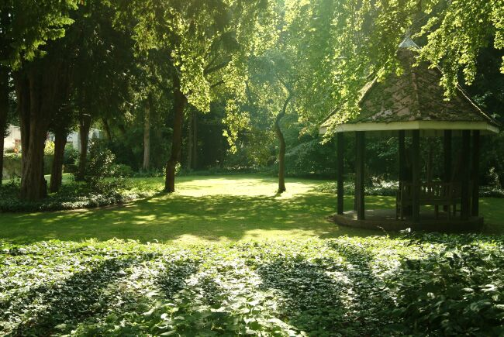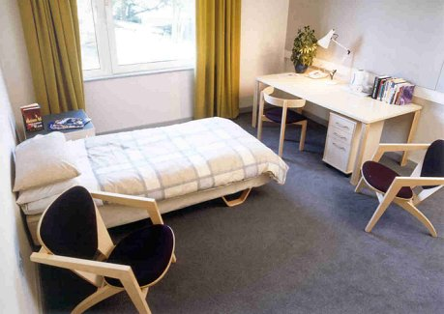

The Long Room: £625.00 No Vat. (This room will have a fixed data projector by 2007.)
The Long room is being refurbished in December this year.
The Long Room is one of our most versatile rooms, seating up to 180 people theatre style, or 80 - 100 Cabaret style, 100 classroom. The room is air-conditioned, & equipped with adjustable lighting, a lectern microphone, 2 lapel microphones, video player, flip chart & OHP as standard.
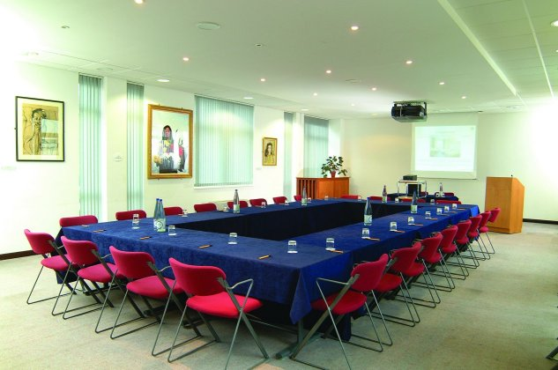

We have broadband facilities and we would be able to have all delegates connected with power at the same time. A fee of £150.00+Vat per day would cover this facility.

Catering:
Tea, coffee & biscuits are served at £1.95+vat per serving.
Tea, coffee & Danish pastries or Pain au Chocolat are served at £2.50+vat per serving.
Standing finger buffet lunch is served at £11.75+Vat per person.
Seated Hot or cold buffet lunch in the Dome Dining Hall will be £17.75+Vat per person.
3 course served dinner in the Dome Dining Hall will be £22.95+Vat.

Dinner would only be available on the 11th July, however, other Colleges would be able to provide dinner so that your delegates get a chance to see other venues!

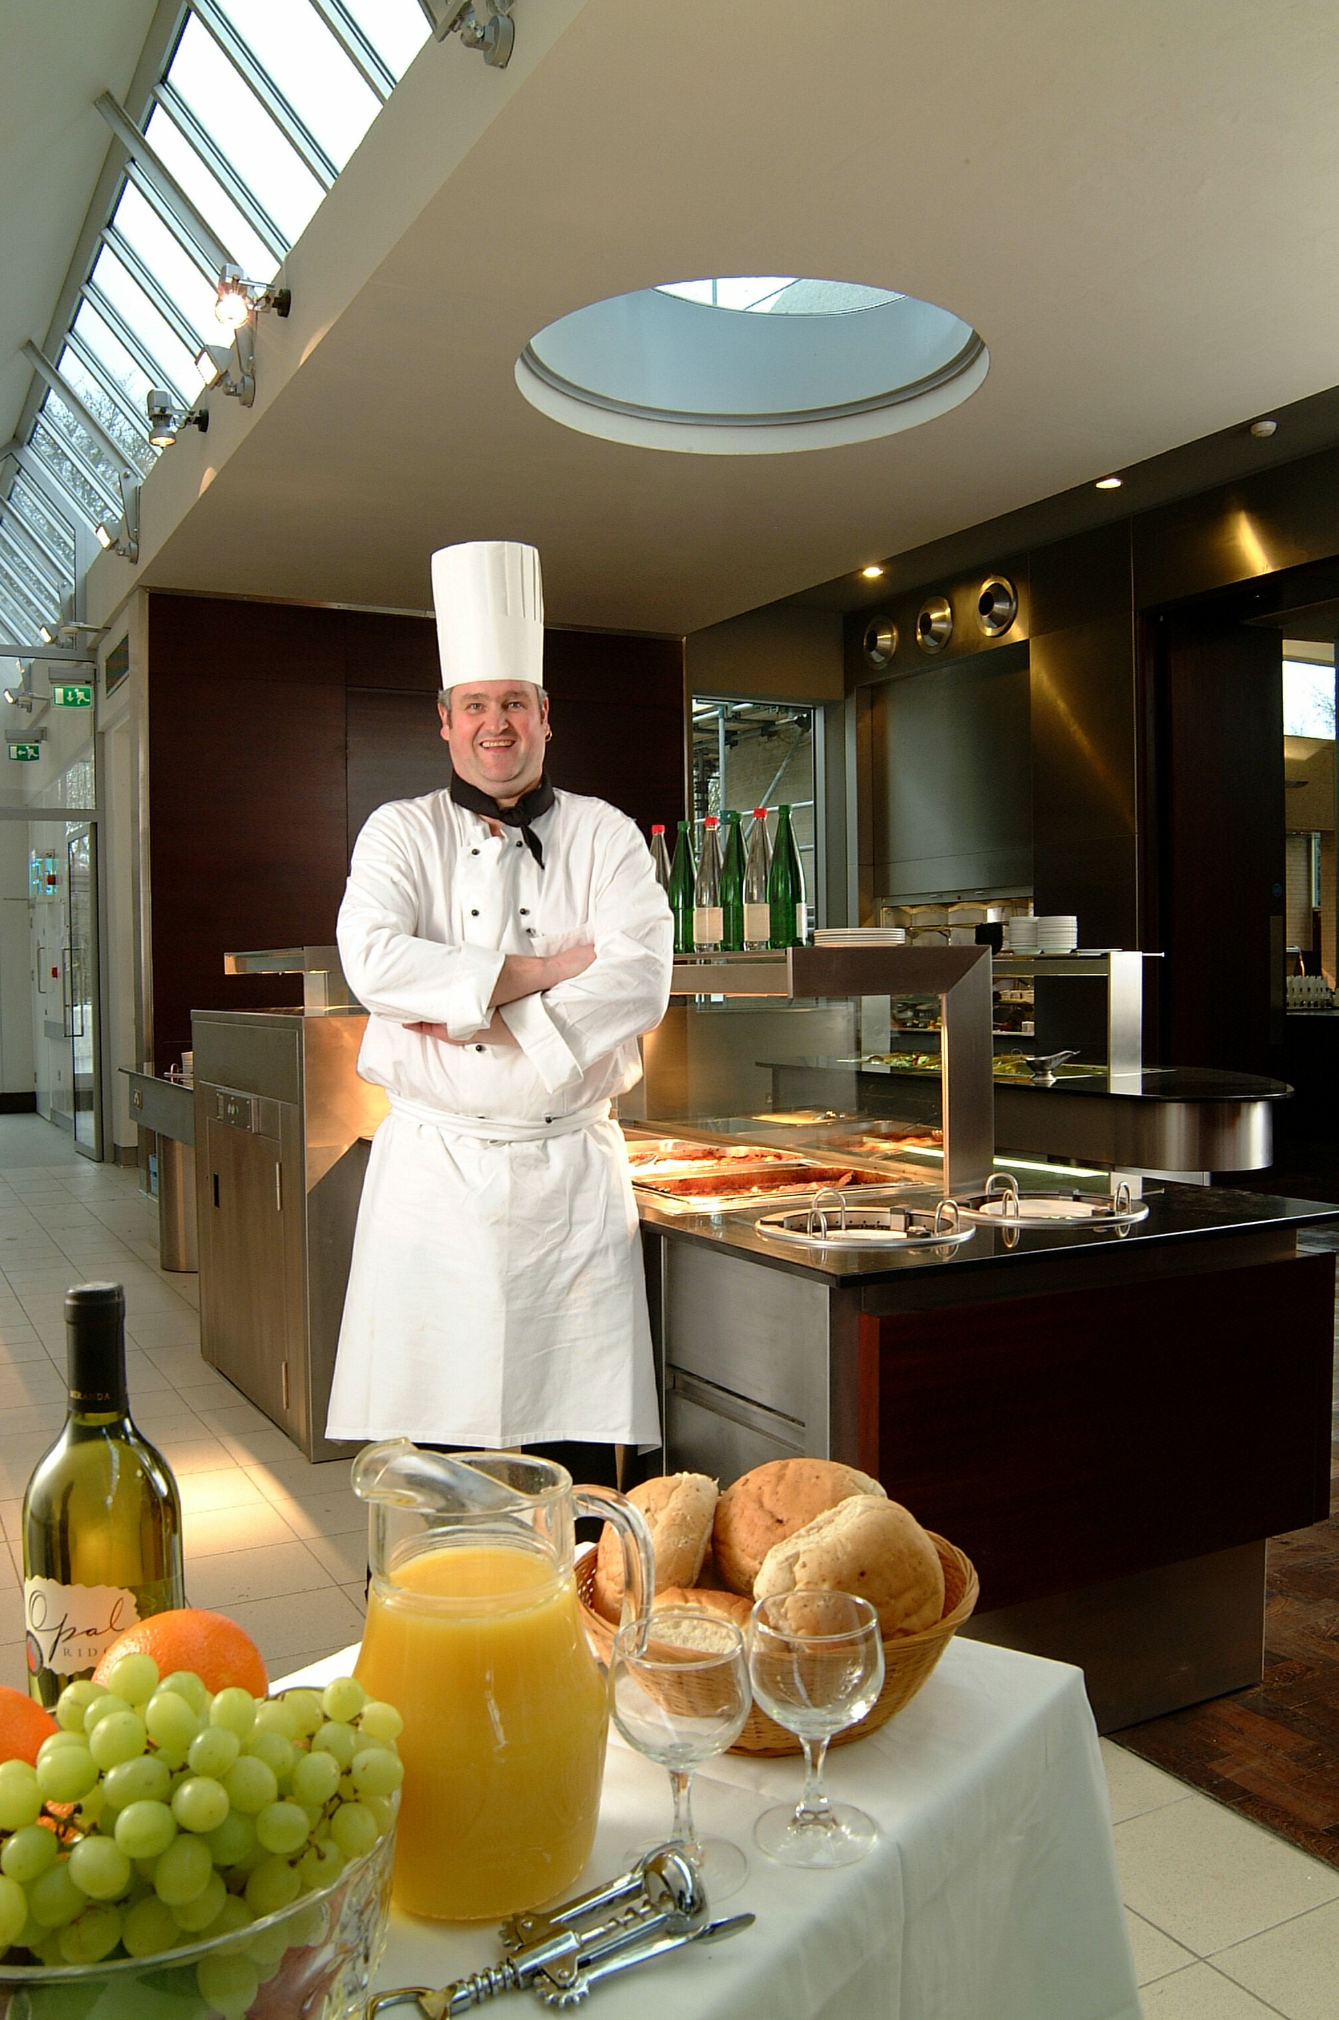

We have car parking available on site & are easily accessible from the M11, A428 & A14.
You may also like to visit our web site at www.newhall.cam.ac.uk.

If you need any further information, or would like to come along for a site visit, please do not hesitate to contact me, as I would be delighted to take you on a tour.

Yours sincerely,

Danielle Williams
Deputy Conference Manager

